Project Day 7. 11. 2019
________________________________________________________________

English Class Project Day 2019

Title: Salt to the Sea

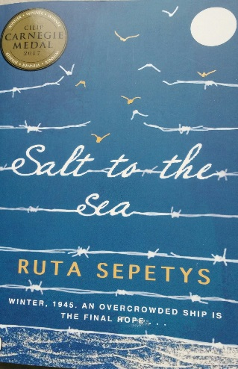

Are you into reading?
Is the smell of a bookshop irresistible to you?
Are you a bookworm?

Then don´t hesitate and join our project!

Aim: interactive reading of historical fiction, comparative creative translations

Contents: reading with comprehension in English of an awarded novel Salt to the Sea by Ruta Sepetys, an amazing plot inspired by the worst maritime disaster in World War II, when young people of your age are hoping to board the Wilhelm Gustloff, a ship that promises safety and freedom. You will spend some time in the premises of the Oxford Bookshop in Hradec Králové with the guidance of an Oxford Publishing House representative.

Output: filling in a worksheet, comparative translations – working as a book translator

Target Group: all levels, all bookworms, all keen readers, all eager bookshop and library goers

Max students: 16

Requirements: a pen, a notebook, a mobile phone with an access to the Internet, a snack

Meeting point: outside Oxford Bookshop, Masarykovo náměstí 527/4, HK, at 8.00 a.m.

Guarantor: Mgr Alice Dinčovová

